Name: Kaysan Shaikh

Roll No: 1146

Div: B

Class: FYBSC(CS)

**Practical No: 06**

**Aim:** To demonstrate Sign Test

Q.1)Following are the amounts of Sulphur oxides (x) (in tons) emitted by large industrial plant in 20 days. 17, 15, 20, 29, 19, 18, 22, 25, 27, 9, 24, 20, 17, 6, 24, 14, 15, 23, 24, 26. Apply sign test to test the hypothesis that population median of X is 21.5 against the alternative hypothesis that is less than 21.5 at 0.05 level of significance.

**Solution:**

x=c(17, 15, 20, 29, 19, 18, 22, 25, 27, 9, 24, 20, 17, 6, 24, 14, 15, 23, 24, 26)

me=21.5

sp=length(x[x>me])

sn=length(x[x<me])

n=sp+sn

pv=pbinom(sn,n,0.5)

los=0.05

if(pv>los){cat("accept Ho")}else{cat("reject Ho")}

**Output:**

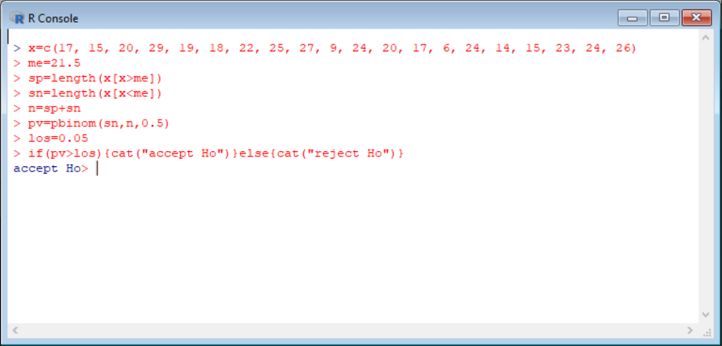

Q.2) Following are data on ten randomly selected specimen of a certain material subjected to stress and the fatigue lives( in kilocycles) 612, 619, 631, 628, 643, 640, 655, 649, 670, 663. Apply sign test to test the hypothesis that population median fatigue life is 625 against the alternative hypothesis that it is greater than 625 at 5% level of significance.

**Solution:**

x=c(612, 619, 631, 628, 643, 640, 655, 649, 670, 663)

me=625

sp=length(x[x>me])

sn=length(x[x<me])

n=sp+sn

pv=pbinom(sn,n,0.5)

los=0.05

if(pv>los){cat("accept Ho")}else{cat("reject Ho")}

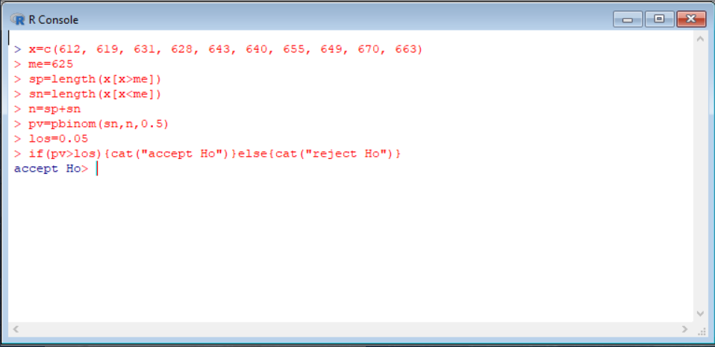**Output:**

Q.3) The following are the measurements of the breaking strength (X) (in pounds) of a certain kind of 2-inch cotton ribbon. 163, 165, 160, 189, 161, 171, 158, 151, 169, 162, 163, 139, 172, 165, 148, 166,172, 163, 187, 173. Test the null hypothesis that population median of X is 160 against the alternative that it is greater than 160 at 0.05 level of significance using Wilcoxon signed rank test.

**Solution:**

x=c(163,165,160,189,161,171,158,151,169,162,163,139,172,165,148,166,172,163,187,173)

wilcox.test(x,alter="greater",mu=160)

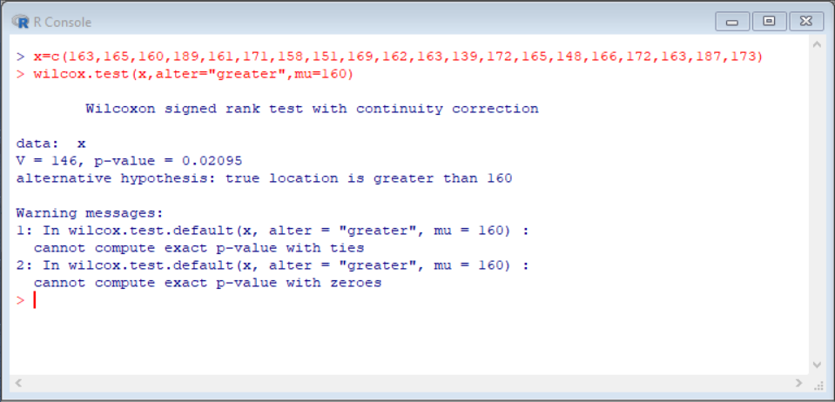**Output:**

**Conclusion:**

Here,los is 0.05 which is greater than p value=0.02095 here we reject Ho.

Q.4) An I.Q test was administered to 5 persons before and after they were trained. The results are given below. Candidate I.Q before training I.Q after training 1 110 120 2 120 118 3 123 125 4 132 136 5125 121. Use sign test to test whether there is increase in I.Q after the training programme at 5% level of significance.

|  |  |  |
| --- | --- | --- |
| **Candidate** | **I IQ before training** | **IIQ after training** |
| 11 | 1110 | 1120 |
| 22 | 1120 | 1118 |
| 33 | 1123 | 1125 |
| 44 | 1132 | 1136 |
| 55 | 1125 | 1121 |

**Solution:**

x=c(110,120,123,132,125)

y=c(120,118,125,136,121)

d=x-y

wilcox.test(d,mu=0,alter="less")

wilcox.test(x,y,paired=T,alter="less")

**Output:**

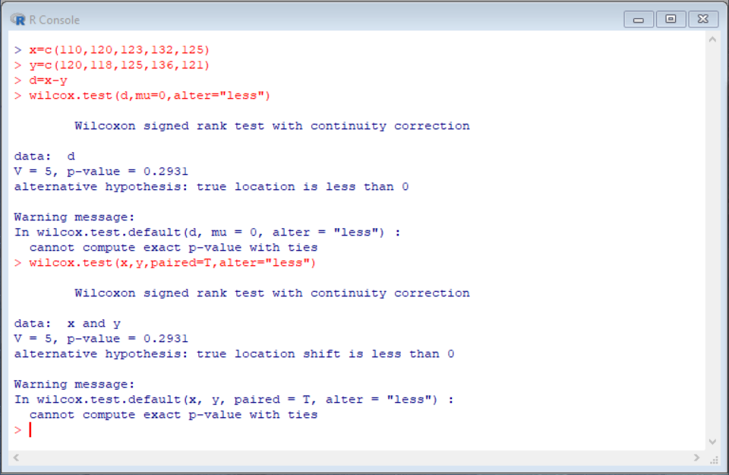

**Conclusion:** Since p>0.05. We can accept Ho.

Q.5)The following are the weights in pounds of 16 persons,before and after a certain weight reducing diet programme of four weeks. Use Wilcoxon’s signed rank test to test whether the weight reducing diet is effective at 0.01 level of significance.

|  |  |  |  |  |  |
| --- | --- | --- | --- | --- | --- |
| **Person** | **Weight Before** | **Weight After** | **Person** | **Weight Before** | **Weight After** |
| 11 | 1147 | 1137.9 | 99 | 1147.7 | 1149 |
| 22 | 1183.5 | 1176.2 | 110 | 2208.1 | 1195.4 |
| 33 | 2232.1 | 2219 | 111 | 1166.8 | 1158.5 |
| 44 | 1161.6 | 1163.8 | 112 | 1131.9 | 1134.4 |
| 55 | 1197.5 | 1193.5 | 113 | 1150.3 | 1149.3 |
| 66 | 2206.3 | 2201.4 | 114 | 1197.2 | 1189.1 |
| 77 | 1177 | 1180.6 | 115 | 1159.8 | 1159.1 |
| 88 | 2215.4 | 2203.2 | 116 | 1171.7 | 1173.2 |

**Solution:**

x=c(147,183.5,232.1,161.6,197.5,206.3,177,215.4,147.7,208.1,166.8,131.9,150.3,197.2,159.8,171.7)

y=c(137.9,176.2,219,163.8,193.5,201.4,180.6,203.2,149,195.4,158.5,134.4,149.3,189.1,159.1,173.2)

d=x-y

wilcox.test(d,mu=0,alter="greater")

wilcox.test(x,y,paired=T,alter="greater")

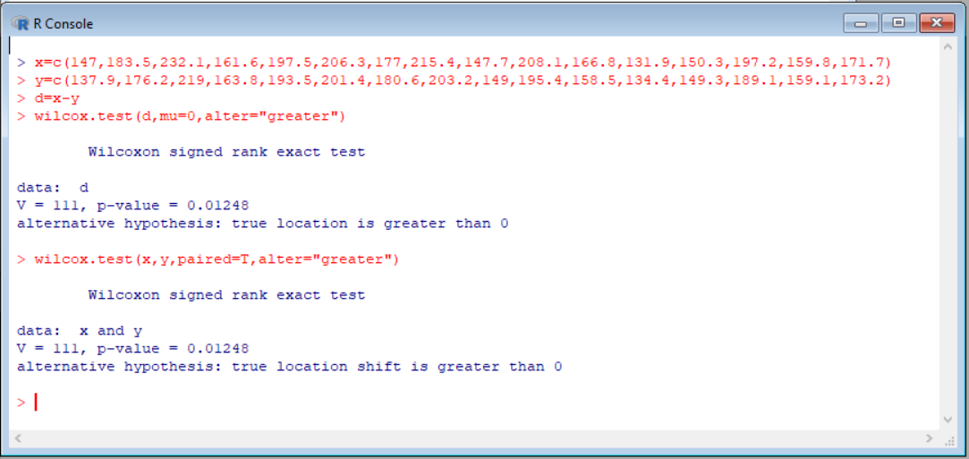**Output:**

**Conclusion:** Since p is 0.0124 and los is 0.01, We reject Ho.